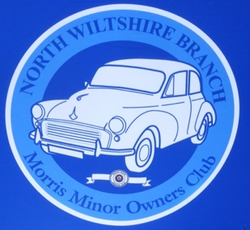
North Wiltshire Branch MMOC

www.northwiltsmmoc.co.uk

Young Member Subscription Form 2022

Enthusiastic about Morris Minors? Under 18 Years of age?

Then become a 'Young Member' of the Branch

The annual subscription fee is £2.00

Name:

Address:

Telephones: Landline Mobile

Email address:

If you have your own car please enter the details here:

Registration Number: Model: Year:

Colour: Name of car:

North Wiltshire MMOC Committee will not share any personal details to a third party
without permission.
I agree for my email address to be used to receive information with regard to branch
activities.

Signed - Name:

Payment of subscription.
Please make payment in cash to the Treasurer, Pam Holmes,at a Branch event
or
by electronic transfer to:
North Wilts MMOC. Sort code: 30-13-35 Account number: 02710987
Reference: Subs/your second name. (e.g. Subs/Holmes)

I have paid by electronic transfer to North Wilts MMOC account on (Date)

If you have any questions then talk to our Treasurer Pam Holmes, telephone number 01285 810524 or by email on pamlynnholmes@icloud.com

